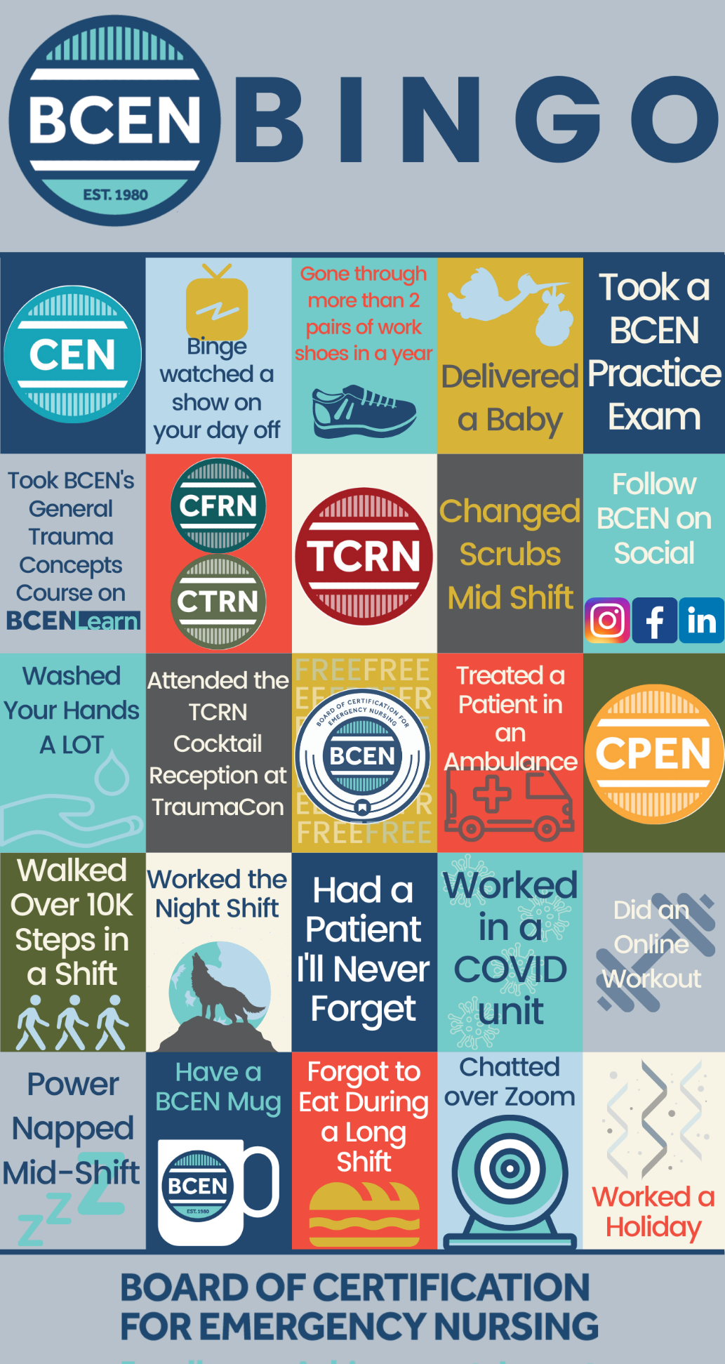

**INSTRUCTIONS:**

* Drag and drop the circles

over the bingo boxes that apply to you

* Fill out your contact information and email back your completed board to **mramirez@bcen.org** for a chance to win.
* **1 lucky winner will be selected to receive a custom #TRAUMANURSE pair of AirPod Pro earbuds!**

**NAME:**

**ADDRESS:**

**EMAIL:**

**PHONE:**